

Analysis of Self Balancing Circuit Using OPAMPfor Sensor Calibration

**Devadharshini.M Dr.Maheswasri Raja**

*Dept of Computer Science and Engineering Dean Innovations*

*Rajalakshmi Institute of Technology. Rajalakshmi Institute of Technology.*

**ABSTRACT**___________________________________________________

This paper presents a high-sensitivity measurement circuit utilizing a self-balancing Wheatstone bridge configuration with an operational amplifier (op-amp) to accurately detect small changes in sensor resistance. The circuit is designed to provide precise calibration and amplification of signals from resistive sensors, such as strain gauges, thermistors, and pressure transducers, commonly used in fields like mechanical testing, environmental monitoring, and biomedical instrumentation. By employing a differential op-amp setup, the circuit effectively minimizes noise and enhances signal integrity, enabling reliable detection of minor variations in sensor parameters. This configuration is particularly beneficial in applications that demand high accuracy, such as force, temperature, and pressure measurement, where the amplified output directly correlates with the physical quantity being measured. The circuit offers adjustable sensitivity and adaptability for various sensor types, making it a versatile solution for precision measurement in industrial, medical, and

scientific applications.

**Keyword: Wheatstone bridge,Op amp,Precise Calibration**



1. **INTRODUCTION**

The Wheatstone bridge, a widely-used circuit configuration, provides a reliable means to detect small changes in resistance by converting them into measurable voltage differences. When combined with an operational amplifier (opamp) in a differential setup, the Wheatstone bridge circuit becomes a highly sensitive system capable of amplifying minute signals while rejecting common-mode noise, ensuring stability and accuracy in measurements. This circuit employs a self-balancing Wheatstone bridge paired with an op-amp to enhance the sensitivity and accuracy of resistive sensors in a wide range of applications. By adjusting the bridge's balance, the system can be easily calibrated to a

known baseline, enabling precise monitoring of even minor deviations in sensor readings. Such a configuration is invaluable in fields that demand high precision, such as biomedical instrumentation, environmental monitoring, and industrial process control. This paper explores the design, operation, and applications of this self-balancing Wheatstone bridge circuit with an op-amp, demonstrating it effectiveness in enhancing the accuracy and reliability of resistive sensor measurements.

1. WORKING PRINCIPLES

1. Bridge Balance and Voltage Division: When the sensor resistance matches the other resistors, the bridge is balanced, and no voltage difference (or very minimal) is present between the two midpoints. However, when the sensor resistance changes due to a physical parameter (e.g., strain or temperature), this balance is disrupted, resulting in a small differential voltage across the midpoints. This differential voltage is proportional to the sensor's resistance change, directly correlating with the physical quantity being measured.

2. Differential Amplification by the Op-Amp: The differential voltage generated by the bridge is very small and often susceptible to noise, making direct measurement challenging. To address this, the op-amp in a differential configuration amplifies the differential voltage while rejecting common-mode signals (such as noise from power supply variations). This amplification increases the sensitivity of the circuit, allowing it to detect small changes in the sensor’s resistance accurately.

3. Output Signal Calibration: The op-amp’s output, which is proportional to the sensor’s resistance change, is a calibrated voltage signal. This signal can then be processed, digitized, or used directly in applications requiring precise readings of the measured parameter, such as strain, temperature, or pressure. The circuit's sensitivity can be adjusted by varying resistor values within the bridge or by configuring the gain of the op-amp, allowing it to accommodate different sensor types and measurement ranges.

III.Purpose of the Self-Balancing Wheatstone Bridge Circuit with Op-Amp:

1. Accurate Detection: Measures small resistance changes in sensors like strain gauges, thermistors, and pressure transducers.

2. Signal Amplification: Amplifies weak signals from the sensor for better readability and sensitivity.

3. Noise Rejection: Reduces noise through differential amplification, ensuring stable and accurate measurements.

4. Precision Measurement: Provides high accuracy, essential for applications requiring precise monitoring of physical changes.

5. Versatile Sensor Interface: Adapts to various resistive sensors, allowing flexibility for multiple measurement applications.

6. Calibration Capability: Allows easy zero-point calibration, ensuring accurate readings over time.

7. Real-Time Monitoring: Enables real-time data acquisition in applications like industrial automation and medical devices.

8. Temperature Compensation: Can be designed to compensate for temperature-induced resistance changes, improving reliability in varying environments.

IV CIRCUIT DIAGRAM

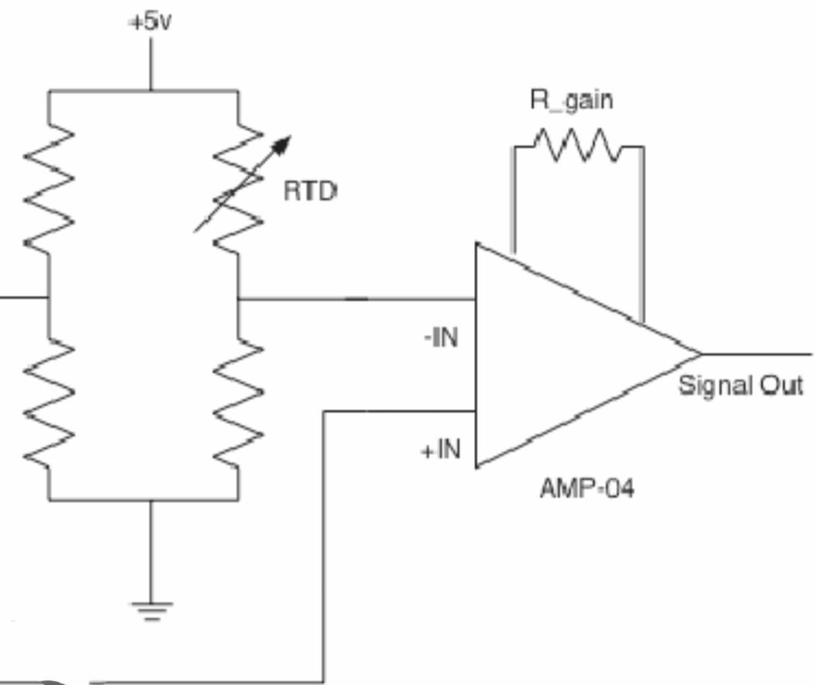

Fig 1: Circuit Diagram of Self Balancing Circuit Using Opamp

V.Proposed System :

The proposed system uses eSim to design and simulate a self-balancing Wheatstone bridge circuit integrated with an operational amplifier. This setup is intended for precision measurement applications, where it detects small resistance changes in sensors, such as strain gauges or thermistors, and converts these changes into a readable voltage output.

In eSim, the Wheatstone bridge is configured with fixed resistors and a sensor resistor, and an LM741 op-amp is added to amplify the bridge’s output signal. Through simulation, the system allows for real-time adjustments of resistor values, enabling calibration and sensitivity analysis before physical implementation. This system provides a cost-effective way to test, optimize, and validate circuit performance, ensuring accuracy, noise rejection, and stability for high-precision applications.

VI.eSIM CIRCUIT

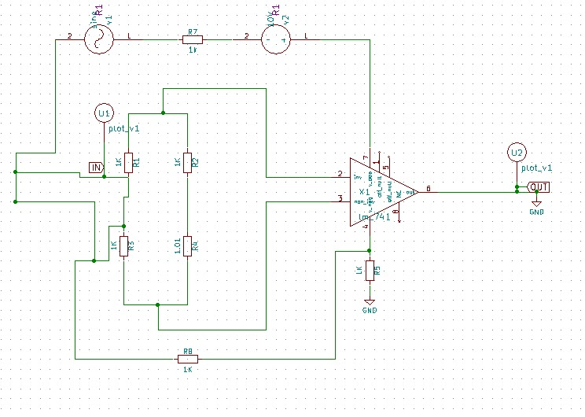

Fig 2: Represents the Circuit diagram of a Self balancing circuit using op amp for sensor calibration within the eSim software environment .

Components Required:

1. DC Power Supply:

Specifications: 10V for the Wheatstone bridge, and typically ±15V for the op-amp (if using a dual supply).

Purpose: Provides the input voltage across the bridge circuit and powers the op-amp.

2. Resistors:

Fixed Resistors: , , with values around 1kΩ each (or other values depending on sensor and desired sensitivity).

Purpose: Form the Wheatstone bridge structure. The resistors help maintain balance when the sensor is at its baseline

resistance.

3. Variable Resistor (Sensor):

Type: Strain gauge, thermistor, pressure transducer, or other resistive sensor.

Purpose: Serves as , whose resistance changes based on the physical quantity (e.g., force, temperature, or pressure)

being measured. This resistance change creates the voltage difference in the bridge circuit.

4. Operational Amplifier (Op-Amp):

Model: LM741 or equivalent (or higher precision op-amps for more sensitive applications).

Purpose: Configured as a differential amplifier, it amplifies the small voltage difference from the unbalanced bridge,

increasing the sensitivity and accuracy of the measurement.

5. High-Resistance Input Resistor (Optional):

Specification: 10MΩ or higher.

Purpose: Used between the bridge output and op-amp input to reduce loading effects and ensure high input impedance,

minimizing measurement errors.

6. Output Load Resistor:

Specification: Typically 10Ω.

Purpose: Placed at the output of the op-amp to ensure stable output voltage

INPUT WAVEFORM:

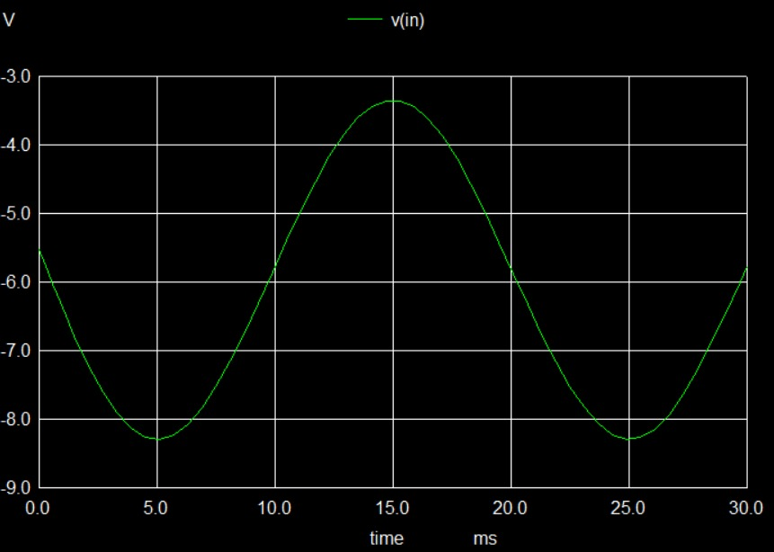

Fig 3: Input Waveform 1 in eSim

OUTPUT WAVEFORM:

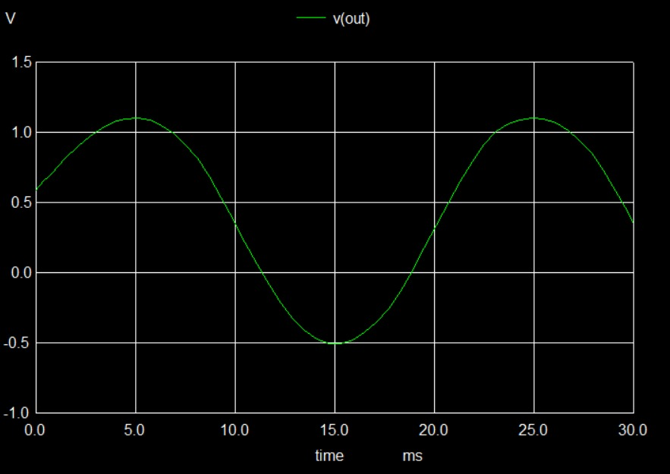

Fig 4:Output Waveform in eSim

PHYTHON PLOT:

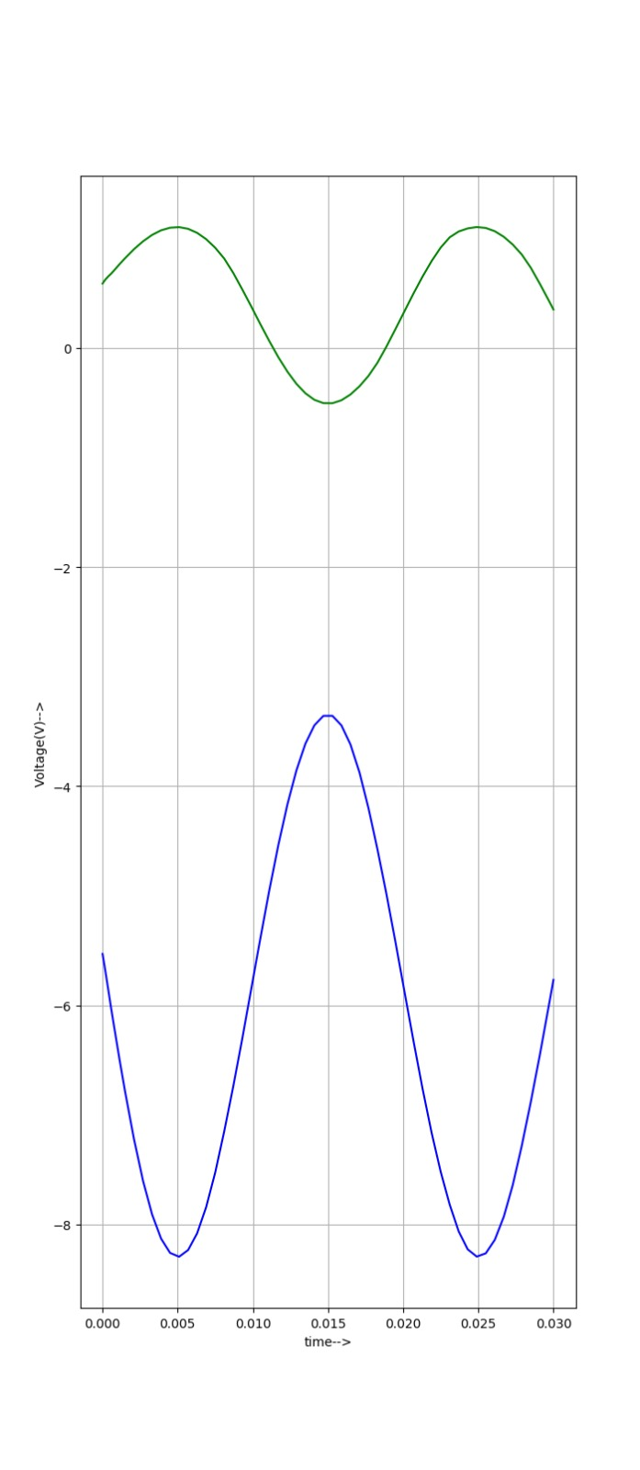

Fig 5 Phython Plot using eSim

VII APPLICATIONS:

1. Strain Gauge Measurement:

Purpose: To measure mechanical stress or strain in structures and materials.

How It Works: Strain gauges change their resistance under stress. The Wheatstone bridge detects these small changes, and the op-amp amplifies the output for accurate measurement.

Applications: Structural health monitoring, bridge and building engineering, and material testing in laboratories.

2. Temperature Sensing:

Purpose: Precise temperature measurement and control.

How It Works: Thermistors or RTDs (Resistance Temperature Detectors) are used in the bridge. Changes in temperature cause resistance variations, which are converted to voltage and amplified for accurate readings.

Applications: Industrial process control, environmental monitoring, HVAC systems, and electronics cooling systems.

3. Pressure Measurement:

Purpose: To monitor fluid or gas pressure in various systems.

How It Works: Pressure transducers in the bridge change resistance with pressure. The circuit detects and amplifies these changes for high-sensitivity pressure readings.

Applications: Automotive pressure sensors, HVAC systems, hydraulic and pneumatic systems, and medical devices like blood pressure monitors.

4. Force and Weight Measurement:

Purpose: To measure force or weight precisely.

How It Works: Load cells with strain gauges convert force into resistance changes, which the bridge and op-amp circuit amplify.

Applications: Digital weighing scales, industrial force sensors, robotics, and packaging systems.

5. Medical Instrumentation:

Purpose: To monitor physiological parameters with high sensitivity.

How It Works: Bioresistive sensors in medical equipment detect biological changes, and the circuit provides precise signal amplification.

Applications: Blood pressure monitoring, respiratory pressure sensing, and glucose monitoring devices.

6. Humidity Sensing:

Purpose: To measure and control humidity levels in environments.

How It Works: Humidity sensors exhibit resistance changes based on moisture content in the air. The bridge and op-amp circuit detect and amplify these changes.

Applications: Environmental control in greenhouses, HVAC systems, and industrial drying processes.

VIII ADVANTAGES:

1.High Sensitivity

2.Noise Reduction

3.Enhanced Accuracy

4.Adaptability

5.Easy Calibration

6.Linear Output

7.Temperature Compenstation

IX DISADVANTAGES :

1.Sensitivity to temperature

2.Limited Output Range

3.Complex Calibration

X CONCLUSION:

Overall, the self-balancing Wheatstone bridge with an op-amp is a valuable and widely applicable circuit for modern precision measurement needs.

XI REFERENCE:

Electronic Instrumentation and Measurements" by David A. Bell: This book covers Wheatstone bridge circuits, sensor applications, and the use of operational amplifiers in instrumentation.

https://images.app.goo.gl/9on4xncQMok9Qqx88